m<Title>

Version 1.0

Class Name | Android
Class Code | K16
Group | mShopping
Teacher | Nguyen Nam Khanh
Project Manager | Nguyen Nam Khanh
Assign Date | Oct-10-2011
Complete Date | Oct-23-2011
Author | mShopping Group
Version | 1.0
Approved By
Approved Date

Table of Contents
1. Introduction 3
1.1 Purpose 3
1.2 Scope 3
1.3 Definitions, Acronyms and Abbreviations 3
1.4 References 3
2. OVERAL Description 3
2.1 Product Perspective 3
2.2 Product Features 3
2.3 Assumptions 4
2.4 Constraints 4
3. FUNCTIONAL REQUIREMENTS 4
3.1 Feature/Component #1: Start page 4
3.1.1 User Interfaces 4
3.1.2 Functional Requirements 5
3.2 Feature/Component #2: Favorite page 5
3.2.1 User Interfaces 5
3.2.2 Functional Requirements 6
3.3 Feature/Component #3: List Location page 6
3.3.1 User Interfaces 6
3.3.2 Functional Requirements 7
3.4 Feature/Component #4: Location Detail Page 7
3.4.1 User Interfaces 7
3.4.2 Functional Requirements 8
3.5 Feature/Component#5: Search Page 9
3.5.1 User Interface: 9
3.5.2 Functional Requirements: 9
3.6 Feature/Component#6: Find way Page 10
3.6.1 User Interface: 10
3.6.2 Functional Requirements: 10
3.7 Feature/Component#7: List Location favorite page 11
3.7.1 User Interfaces 11
3.7.2 Functional Requirements 12
3.8 Feature/Component #8: Message 13
4. Revision History 13

Introduction
Today, the popularity of mobile phones with software applications, specially phones use the Android OS. So, we want to develop an application mobile to help user have a better life. mShopping what we’re developing, is a software, runs Android platform to help user go to shopping easier.

Purpose
mShopping runs in Android operation system, using for user to find any location such as bookshop, fashion shop, gas station, bank,… A user can use this software with any mobile runs in Android operation system, any location in HCMC. Helpful, quickly, easy to use are basic requirement of our software.

Scope
mShopping Software Requirement presents feature of our software.

Definitions, Acronyms and Abbreviations
Term | Definitions, Acronyms and Abbreviations
 | None

References
www.android.developer.com

OVERAL Description

Product Perspective
mShopping software runs on Android OS version 2.1. This application is developed on Eclipse, ADT plug-in version 12, base on java language.

Product Features
Main features:
Find shopping location.
Store favorite location.
Find the shortest way to go to shopping.

Assumptions
Google API is available.

Constraints

FUNCTIONAL REQUIREMENTS

Feature/Component #1: Start page

User Interfaces
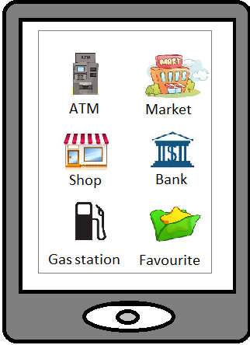

Functional Requirements

Current screen | Description | Action | Next screen
Start page | List shop in in alphabetical order. Users can scroll to view all shop. | Tag shop’s icon to view | List location page
Start page |  | Tag Favorite icon | Favorite page

Feature/Component #2: Favorite page

User Interfaces

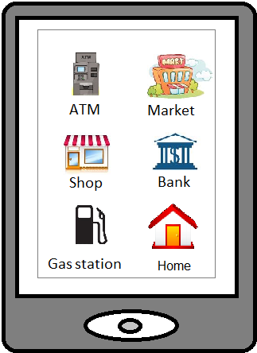

Functional Requirements

Current screen | Description | Action | Next screen
Favorite | List shops which user tagged. | Tag shop’s icon to view | List location favorite page
Live search |  | Press Back button | Start page

Feature/Component #3: List Location page

User Interfaces

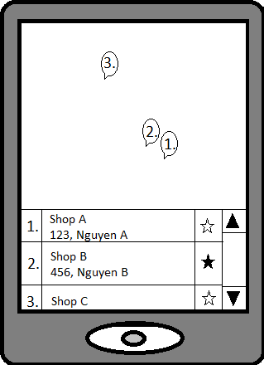

Functional Requirements
Current screen | Description | Action | Next screen
List location page | Display location of shop in map.  List information of shop: name, address, the level of user favorite. | Click location in map | Detail location page
List location page |  | Tag information of shop | Search page
List location page |  | Click start icon in information of page, program increase the level of favorite of shop | List location page

Feature/Component #4: Location Detail Page

User Interfaces
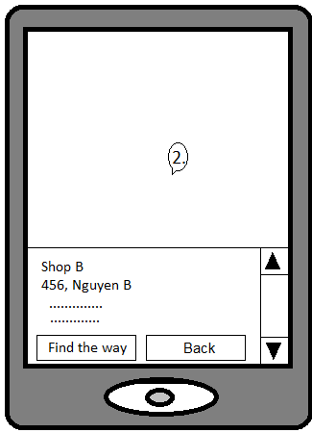

Functional Requirements

Current screen | Description | Action | Next screen
Location detail page | Display location of a shop which user selected in map.  List information of shop: name, address, the level of user favorite, promotion. | Click find the way button | Find Way Page
Location detail page |  | Click Back button | List location page

Feature/Component#5: Search Page

User Interface:
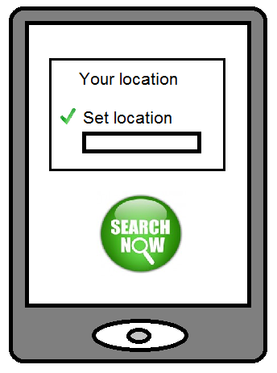

Functional Requirements:
Current screen | Description | Action | Next screen
Search Page | Software will display two options for user chose the way how to go there.
Search Page | Search a way what connect your location to location to be chosen. This result has to be a shortest way. | Touch Your location checkbox
Search Page | Search a way what connect your location to be set to location you chose before. This result has to be a shortest way. | Touch Set location checkbox
Search Page | Software starts search process. | Touch Search button | Find way Page

Feature/Component#6: Find way Page

User Interface:
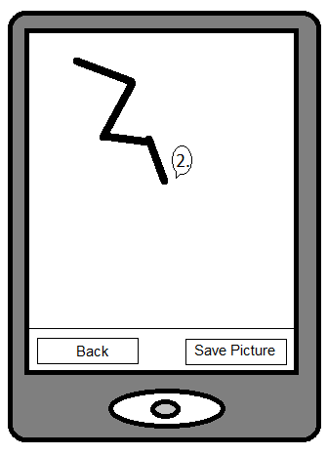

Functional Requirements:
Current screen | Description | Action | Next screen
Find way Page | Software will display a line on the map. This line connects your location (or location is set) to location where you want to go. The result is the shortest way you can follow.
Find way Page | Software will save this map with the way just found. User can use this picture next time without run software again. | Touch Save Picture button | Start page
Find way Page | If you don’t want to go there because the way is so hard to go (…), you can chose other location | Touch Back button | List Location Page

Feature/Component#7: List Location favorite page

User Interfaces
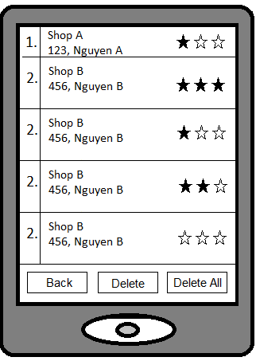

Functional Requirements
Current screen | Description | Action | Next screen
List Location favorite page | Display information of shops which user tagged favorite in order: name, address, the level of user favorite. | Tag information of shop | Location detail page
List Location favorite page | Increase the level of favorite of shop when user click start icon. | Click start icon | List location favorite page
List Location favorite page |  | Click Back button | Favorite page
List Location favorite page | Delete one level of favorite of shop. | Click Delete button | List Location favorite page
List Location favorite page | Delete all level of favorite of shop. | Click Delete all button | List Location favorite page

Feature/Component #8: Message

Message ID | Messages | Description
Msg001 | Do you want to delete this item? | Ask when the user wants to delete an bookmark or history item
Msg002 | Do you want to delete all bookmarks? | Ask when the user wants to delete all bookmarks
Msg003 | Do you want to delete all historical searches? | Ask when the user wants to delete all historical items
Msg004 | This item already exist in bookmarks | Ask when the user inserts a shop to bookmarks but it already exist.

Revision History
Date | Version | Description | Revised by

---------- End of Document ----------

